**Replaced my note-taking apps with a cross-platform, easy-to-use plain-text stack**

Most [note-taking apps](https://www.xda-developers.com/best-private-note-taking-apps-for-ultimate-security/) promise structure, but at some point, they just add friction. I’ve probably tried about a dozen notes apps by now, and started wondering if they’re actually making the process more complicated. I lose track of things, databases get heavy, syncing gets weird, and exporting my own notes turns into a whole project. So, I thought back to what I used to do before all these apps — plain text files. Turns out, this old-school approach was simpler and more flexible once I gave it real structure.

Plain text is cross-platform by default, working seamlessly across Windows, macOS, Linux, iOS, and Android. It also doesn’t lock you into one particular vendor since the files are readable with any text editor. The real trick isn’t even in the text files, but how you structure them. Once I started treating my notes like a lightweight filesystem, I got the flexibility of a database but without the overhead.

Let me show you the plain-text stack I landed on, and more importantly, the [folder structure](https://www.xda-developers.com/file-structures-naming-conventions-organizing-files/) that makes it scale.

**What do I use for notes now?**

**If it can open and save a text file, it works**

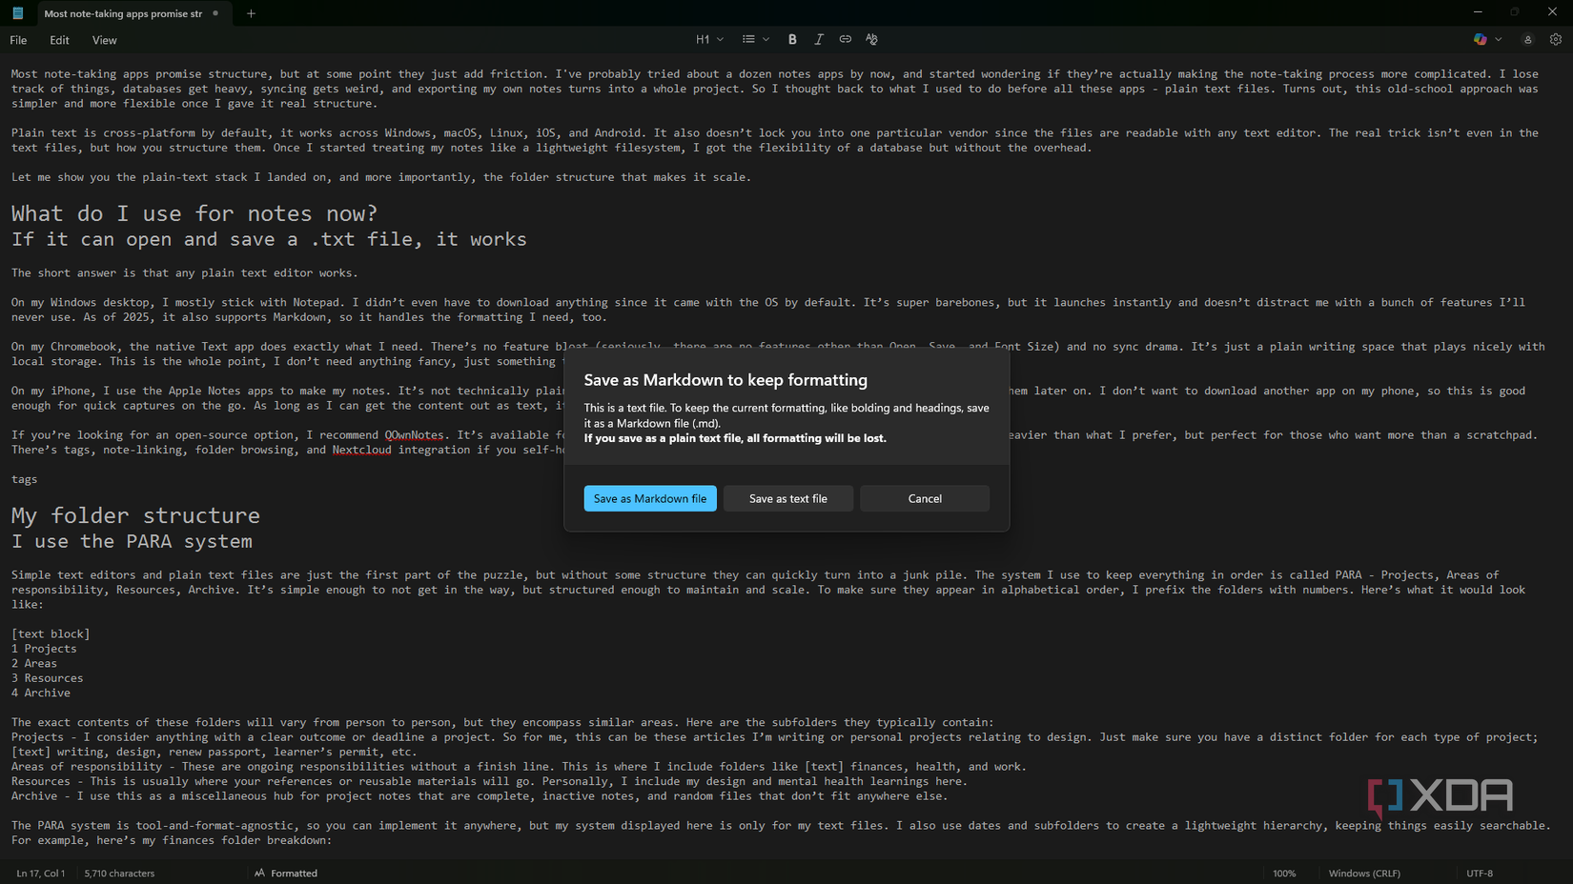

The short answer is that any plain text editor works, as long as it lets me create .txt or .md files.

On my Windows desktop, I mostly [stick with Notepad](https://www.xda-developers.com/notepads-best-feature-is-its-simplicity-and-microsoft-is-slowly-taking-it-away/). It’s super barebones, but it launches instantly and doesn’t distract me with a bunch of features I’ll never use. As of 2025, it also supports Markdown, so it handles the formatting I need, too.

On my Chromebook, the native Text app does exactly what I need. There’s no feature bloat (seriously, there are no features other than Open, Save, and Font Size) and no sync drama. It’s just a plain writing space that plays nicely with local storage.

On my iPhone, I use the Apple Notes app. It’s not technically plain text, but I export the notes as .txt files and transfer them later on. I don’t want to download another app on my phone, so this is good enough for quick captures on the go. As long as I can get the content out as text, it fits the stack.

If you’re looking for an open-source option, I recommend [QOwnNotes](https://www.qownnotes.org/" \t "_blank). It’s available for macOS, Linux, and Windows, and supports Markdown. It’s a little heavier than what I prefer, but perfect for those who want more than a scratchpad. There are tags, note-linking, folder browsing, and Nextcloud integration if you self-host.

**My folder structure**

**I use the PARA system**

[Simple text editors](https://www.xda-developers.com/reasons-vs-code-is-the-best-text-editor-even-if-youre-not-a-developer/) and plain text files are just the first part of the puzzle, but without some structure, they can quickly turn into a junk pile. The system I use to keep everything in order is called PARA — Projects, Areas of responsibility, Resources, Archive. It’s simple enough not to get in the way, but structured enough to maintain and scale. To make sure they appear in alphabetical order, I prefix the folders with numbers. Here’s what it would look like:

1 Projects  
2 Areas  
3 Resources  
4 Archive

The exact contents of these folders will vary from person to person, but they encompass similar areas:

* **Projects** - I consider anything with a clear outcome or deadline as a project. It could be these articles I’m writing or personal projects relating to design. Just make sure you have a distinct folder for each type of project: writing, design, learner’s permit test, etc.
* **Areas of responsibility** - These are ongoing responsibilities without a finish line. This is where I include folders like finances, health, and work.
* **Resources** - This is usually where your references or reusable materials will go. Personally, I include my design and mental health learning here.
* **Archive** - I use this as a miscellaneous hub for project files that are complete, inactive notes, and random files that don’t fit anywhere else.

The PARA system is tool-and format-agnostic, so you can implement it anywhere, but the system I'm displaying here only has text files. I also use dates and subfolders to create a lightweight hierarchy, [keeping things easily searchable](https://www.xda-developers.com/organize-search-files-effectively-windows-explorer/). For example, here’s my finance folder breakdown:

1 Areas  
> Finances  
>> Budget  
>>> 2025-04  
>>> 2025-05  
>>> 2025-06  
>> Bills  
>>> 2025-04  
>>> 2025-05  
>>> 2025-06  
Etc.

The PARA system really helps me avoid the dilemma of one giant folder with a bunch of random notes.

**Syncing and storage**

**Keeping things portable**

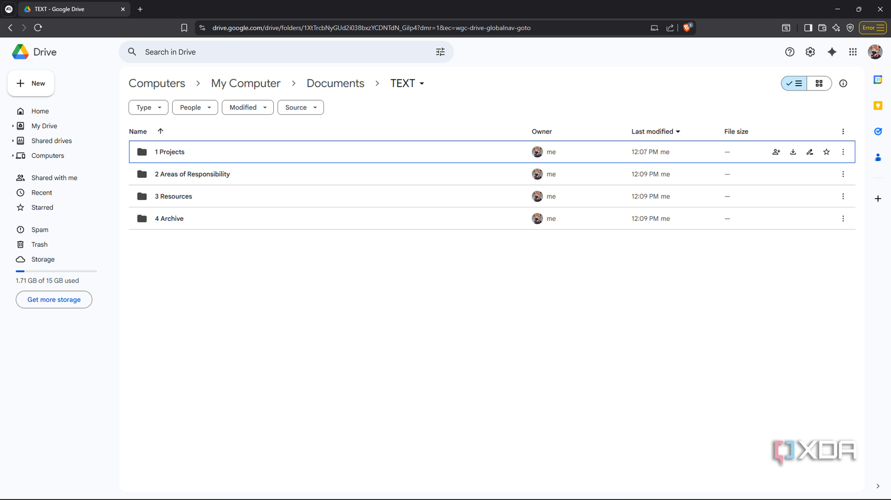

Plain text doesn’t take up much space, so you don’t need a complicated setup to [keep everything in sync](https://www.xda-developers.com/i-self-host-syncthing-to-sync-files-between-my-pc-mac-nas-and-other-devices/) and stored. Personally, I just use the Google Drive desktop app with folders set to sync — it’s boring, and I know not everyone deems it privacy-forward, but it works seamlessly. If you want something more secure, I recommend [Nextcloud](https://nextcloud.com/" \t "_blank) — an open-source, [self-hostable cloud storage system](https://www.xda-developers.com/convert-raspberry-pi-zero-2w-into-self-hosted-cloud-storage-service/). But it takes more effort to set up.

For syncing files across my laptop and PC, I use [Syncthing](https://syncthing.net/" \t "_blank). It’s open-source, peer-to-peer, and doesn’t rely on the cloud at all. For quick one-offs, I keep [Snapdrop](https://snapdrop.net/" \t "_blank) bookmarked. It works like Airdrop between my iPhone and desktop browser. After being acquired by Limewire, I can’t say with certainty whether Snapdrop is open-source anymore, so you can try [PairDrop](https://pairdrop.net/" \t "_blank), which is open-source.

**Plain text wins**

A solid folder structure combined with plain text files beats a [feature-heavy notes app](https://www.xda-developers.com/note-taking-app-is-onenote-on-steroids/) every time. My notes remain searchable, scalable, organized, and easy to retrieve, regardless of my device. So it doesn't matter what device you’re working on, the focus stays on capturing and using information, not wrestling with software.